*CS5330: Pattern Recognition and Computer Vision*

Project 2: Content Based Image Retrieval

Hardik Devrangadi devrangadi.h@northeastern.edu

**Content Based Image Retrieval – Matching / Pattern Recognition**

This project aims to perform Content Based Image Retrieval on a dataset of images, based on a selected target image. In this project, several tasks are performed to find images in the dataset based on generic characteristics of the image such as color, texture, and their spatial layout. In this project, the use of different color spaces, histograms, spatial and texture features are widely used.

For the tasks, the entire project is divided into two parts –

* $featureVectorDB.cpp$– All the images in the database are scanned and their feature vectors are extracted, based on several image characteristics. This data is stored in a CSV file.
* $imageMatch.cpp$– A target image is given along with the image database and the feature vectors. It computes the feature vector for the target image and gives the top N matches based on a distance metric.

**Tasks**

**Task 1: Baseline Matching**

* *Feature Vector:* 9x9 square at the middle of the image
* *Distance Metric:* Sum-of-Squared-Difference
* 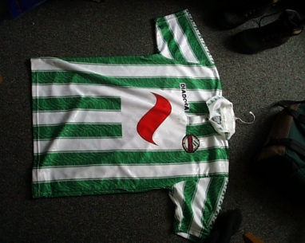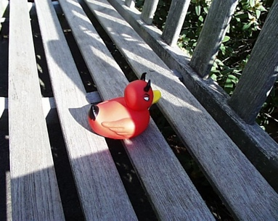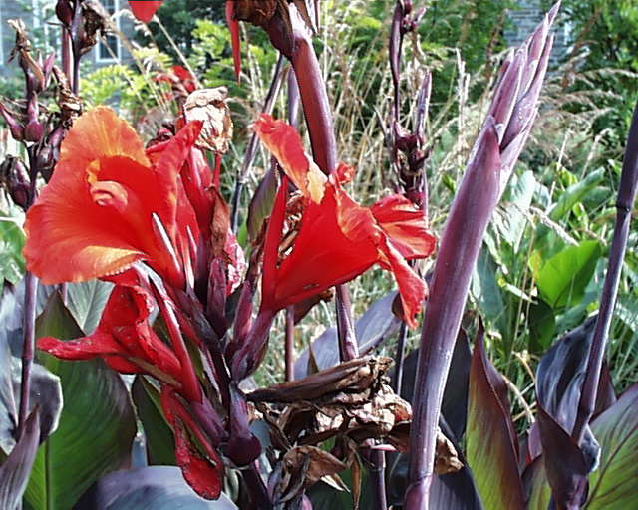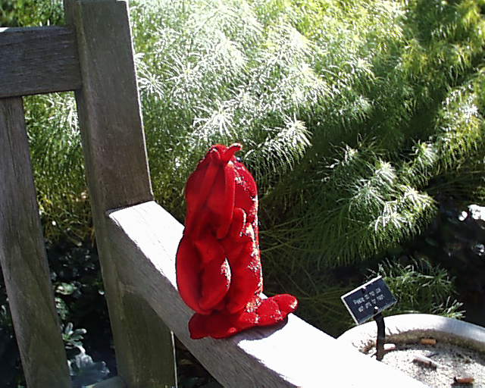*Target Image:* pic.1016.jpg

pic.0986.jpg

pic.0233.jpg

pic.0641.jpg

pic.1016.jpg

**Task 2: Histogram Matching**

* *Feature Vector:* L2 Normalized Three Dimensional BGR Histogram for entire image with 8 bins for each color
* *Distance Metric:* Histogram Intersection with equal weightage
* *Target Image:* pic.0164.jpg

pic.0898.jpg

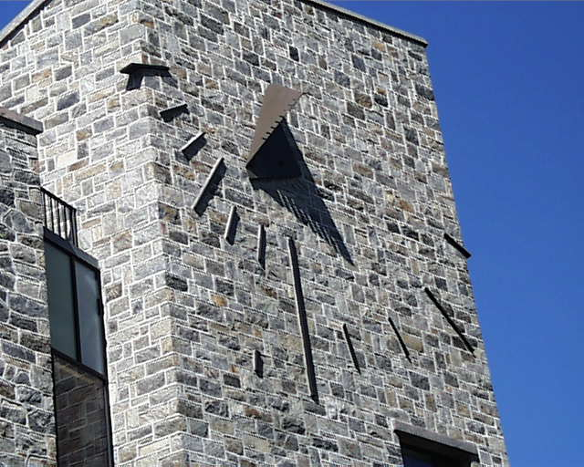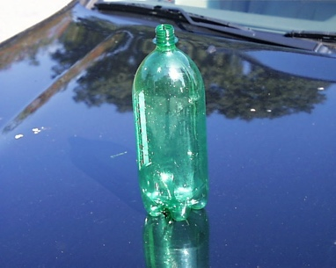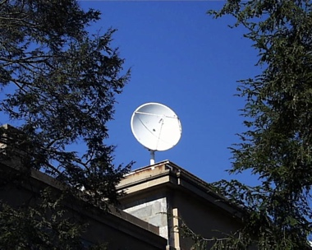

pic.0092.jpg

pic.0110.jpg

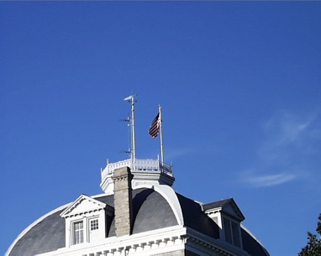

pic.0164.jpg

Even though the green bottle is placed on the hood of the black car in pic.0898.jpg, based on the histograms that were generated, the background has a blue color like that of the target image, which seems interesting.

**Task 3: Multi-Histogram Matching**

* *Feature Vector:* Concatenate 2x2 Grid BGR Histograms for 4 quadrants with 8 bins for each color
* *Distance Metric:* Sum-of-Squared-Difference
* *Target Image:* pic.0274.jpg

pic.1031.jpg

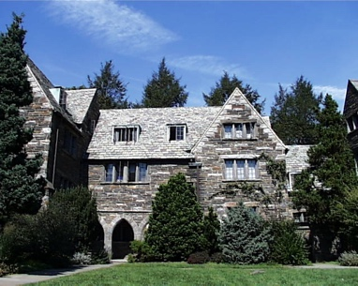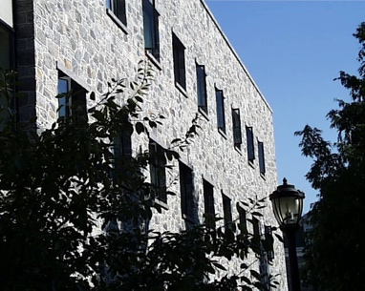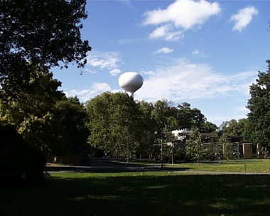

pic.0409.jpg

pic.0273.jpg

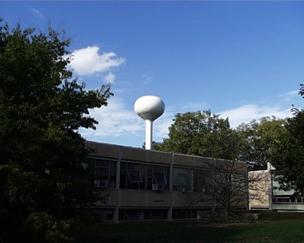

pic.0274.jpg

In the example provided in the prompt, pic.0273.jpg is the closest match, which makes sense visually, however in this case as 4 quadrants are considered, instead of the top and bottom halves, this image is not the closest match. When the image is divided in two halves, the bright sky and dark bottom half are similar, however when divided in a 2x2 grid, this changes.

**Task 4: Texture and Color**

* *Feature Vector:*
  + Texture Histogram – 2D Histogram of Sobel Gradient Orientation and Magnitude
  + Color Histogram – L2 Normalized Three Dimensional BGR Histogram for entire image with 8 bins for each color
* *Distance Metric:* Histogram Intersection with equal weightage
* *Target Image:* pic.0535.jpg

pic.0732.jpg

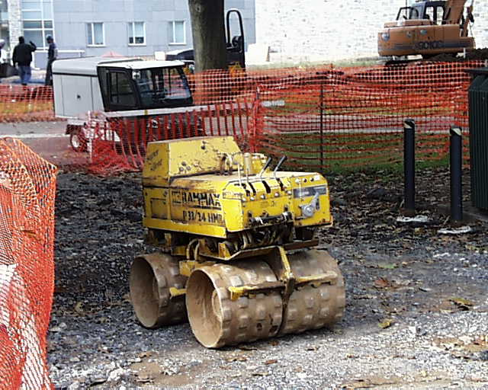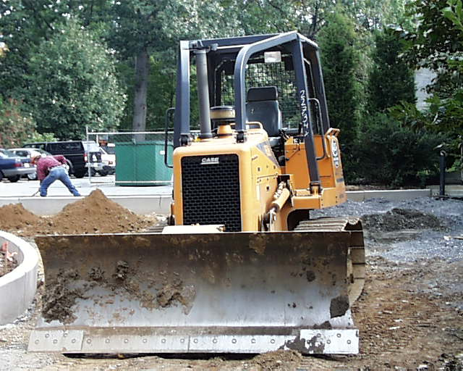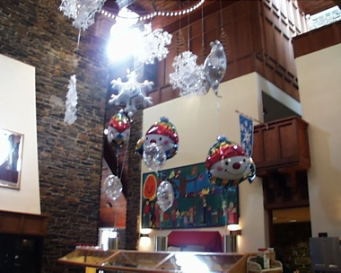

pic.0731.jpg

pic.0628.jpg

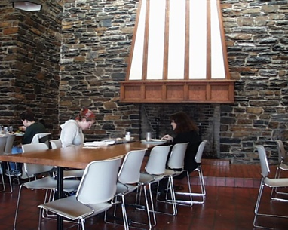

pic.0535.jpg

The same target image for Task 2 with:

* *Feature Vector:* L2 Normalized Three Dimensional BGR Histogram for entire image with 8 bins for each color
* *Distance Metric:* Histogram Intersection with equal weightage
* *Target Image:* pic.0535.jpg

pic.0628.jpg

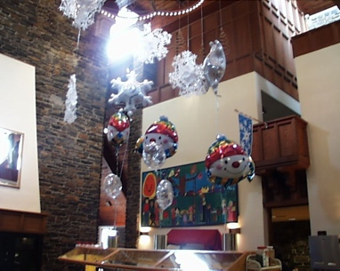

pic.0731.jpg

pic.0233.jpg



pic.0535.jpg

The same target image for Task 3 with:

* *Feature Vector:* Concatenate 2x2 Grid BGR Histograms for 4 quadrants with 8 bins for each color
* *Distance Metric:* Sum-of-Squared-Difference
* *Target Image:* pic.0274.jpg

pic.0973.jpg

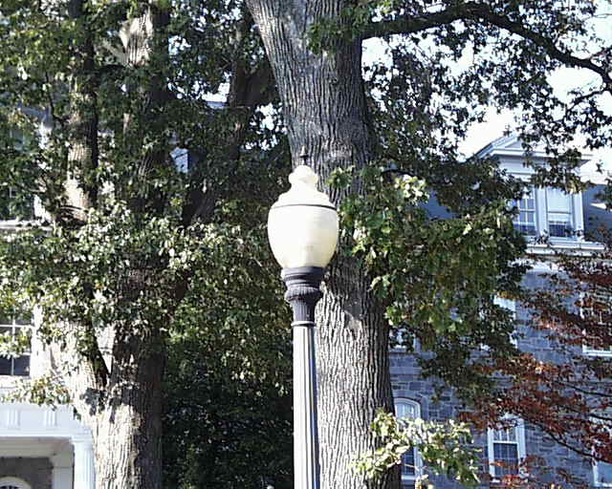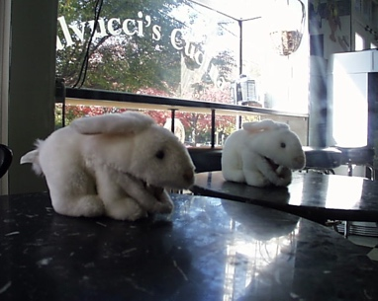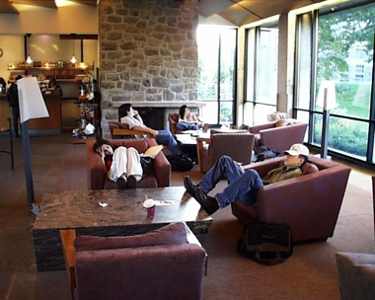

pic.0975.jpg

pic.0355.jpg



pic.0535.jpg

**Task 5: Custom Design**

In Task 5, the target image consisted of a blue recycle bin.

To recognize all images in the dataset, that are like the target image, the target image must be analyzed. To identify an image with a blue bin the texture must be determined as well as the color. To identify the blue bin in all the images, the feature vectors from task 4 are used. However, this scenario is not favorable as the blue bin could be placed anywhere in the image or occupy a small region of the image which makes it impossible to identify. In the dataset, however, many images have the bin placed close to the middle of the image, which adds some consistency in this case that can be exploited to create a design that searches for the bin only in the middle section.

Therefore, the best approach is followed in this task, the image is divided into 9 boxes, i.e, a 3x3 grid, and the texture and color feature vectors from Task 4 are applied only to the middle section.

The caveat for this algorithm is that it works only if the subject is located at the center of the image.

For Test 1:

* *Feature Vector:*

*Applied to only the center section of the image:*

* + Texture Histogram – 2D Histogram of Sobel Gradient Orientation and Magnitude
  + Color Histogram – L2 Normalized Three Dimensional BGR Histogram for entire image with 8 bins for each color
* *Distance Metric:* Histogram Intersection with equal weightage
* *Target Image:* pic.0289.jpg

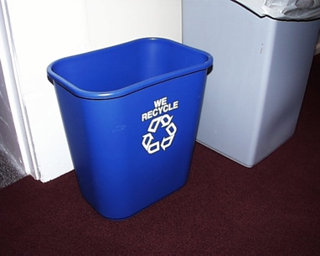

pic.0287.jpg

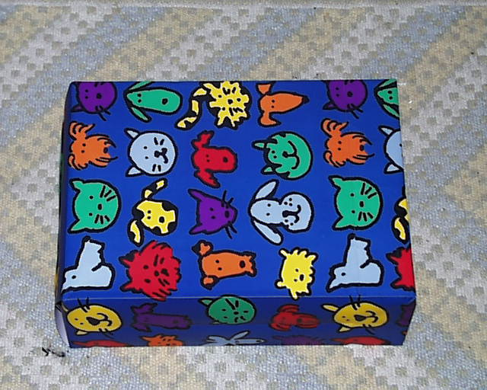

pic.0665.jpg

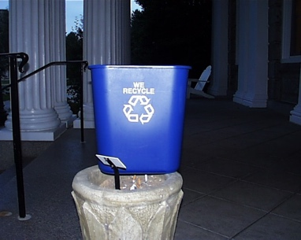

pic.0288.jpg

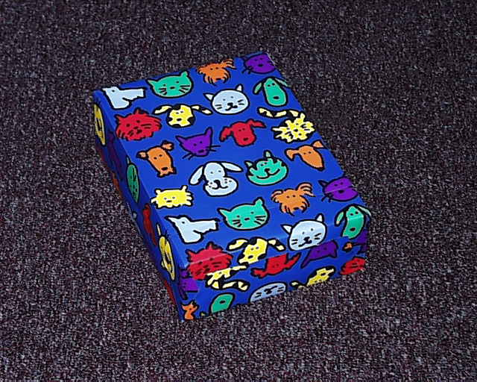

pic.0666.jpg

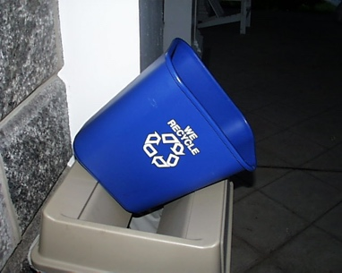

pic.0289.jpg

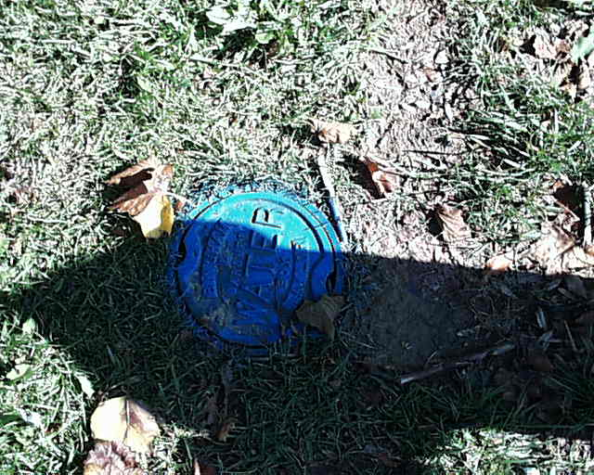

pic.0488.jpg

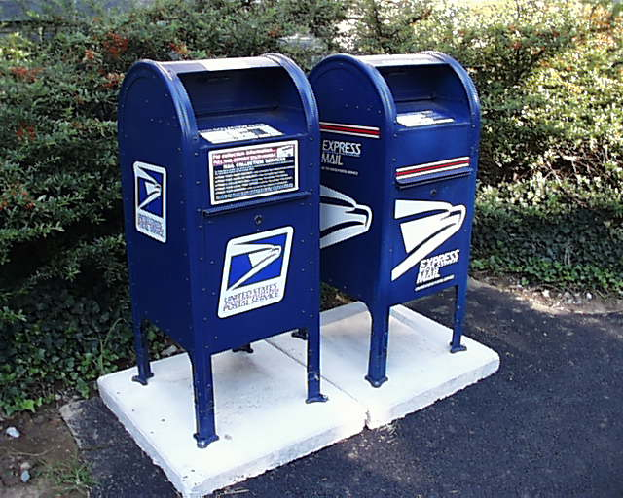

pic.0214.jpg

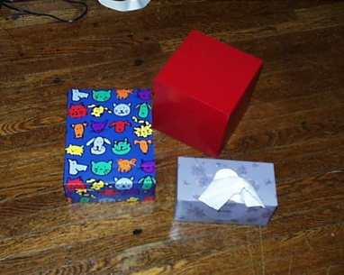

pic.0667.jpg

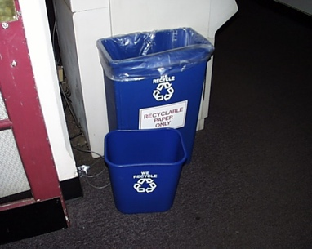

pic.0291.jpg

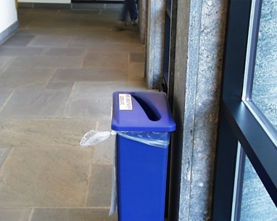

pic.0920.jpg

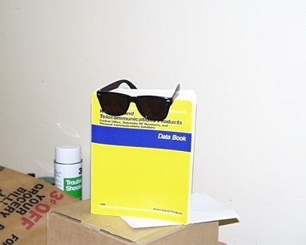

pic.0407.jpg

For Test 2:

* *Feature Vector:*

*Applied to only the center section of the image*

* + Texture Histogram – 2D Histogram of Sobel Gradient Orientation and Magnitude
  + Color Histogram – L2 Normalized Three Dimensional BGR Histogram for entire image with 8 bins for each color
* *Distance Metric:* Histogram Intersection with equal weightage
* *Target Image:* pic.0288.jpg



pic.0288.jpg



pic.0287.jpg



pic.0920.jpg



pic.0666.jpg

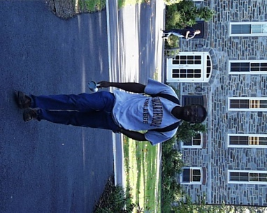

pic.0486.jpg



pic.0665.jpg

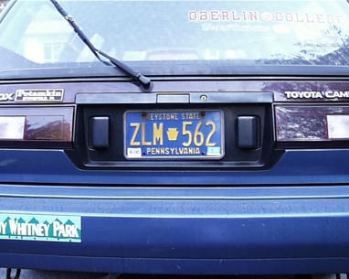

pic.0482.jpg

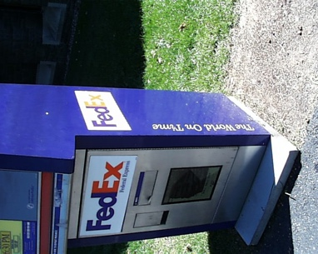

pic.0133.jpg

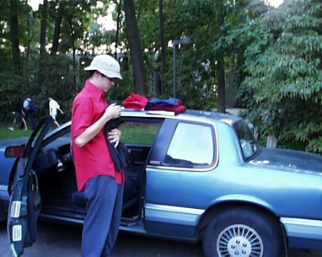

pic.0477.jpg



pic.0488.jpg

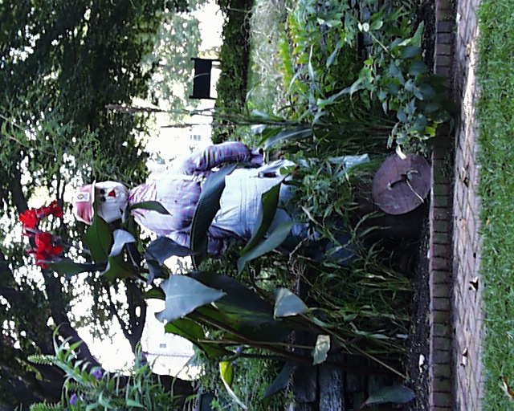

pic.0432.jpg

In the examples above, labeled as Test 1 and Test 2, the images of the blue bins are not consistent. The observation here, is that the blue gifts, postboxes have the similar texture of straight lines and similar color, which is the reason why they are being matched to the target image. This algorithm was also tested on red ball in the image, the observation made is that this design works well on images with regular lines with intersecting horizontal and vertical edges rather than irregular objects.

**Extensions**

These are the extensions, where Gabor filters are used to perform texture analysis using the existing functions that were already used for the 5 tasks. The implementation of Gabor filters along with varied color matching and spatial differences of the image. After applying the filter, the mean and standard deviation is calculated which is then normalized to obtain the final feature vector.

[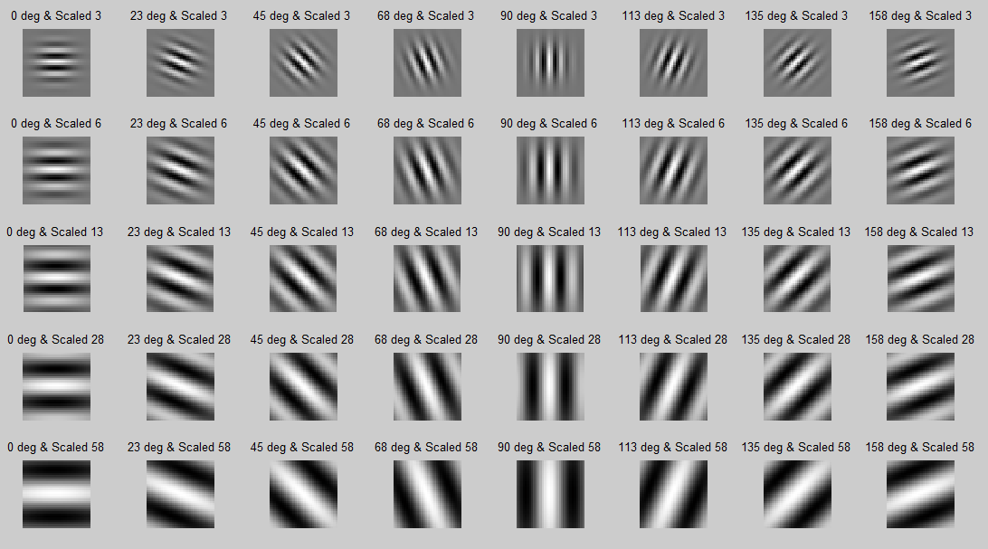](https://stackoverflow.com/questions/30071474/opencv-getgaborkernel-parameters-for-filter-bank)

Gabor Filter – 5 scales and 8 orientations [(click for original source)](https://stackoverflow.com/questions/30071474/opencv-getgaborkernel-parameters-for-filter-bank)

The Gabor Filter is used commonly for Optical character recognition, iris recognition and fingerprint recognition. However, as these types of images are not present in the “Olympus” dataset, these filters are applied on regular images for understanding.

**Extension 1: Gabor Texture**

* *Feature Vector:* Gabor Filters applied in different scales and orientations
* *Distance Metric:* Sum-of-Squared-Difference
* *Target Image:* pic.0684.jpg

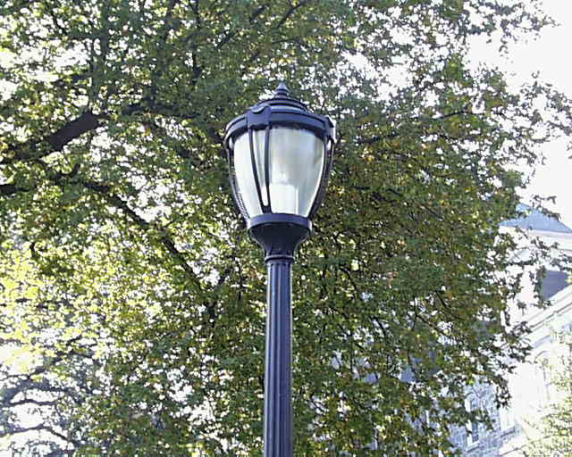

pic.0903.jpg

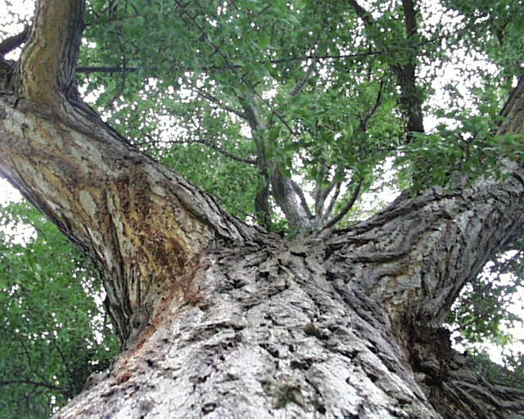

pic.0684.jpg

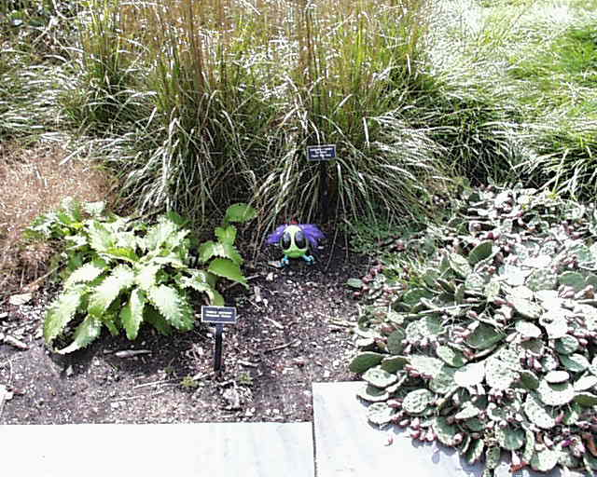

pic.0704.jpg

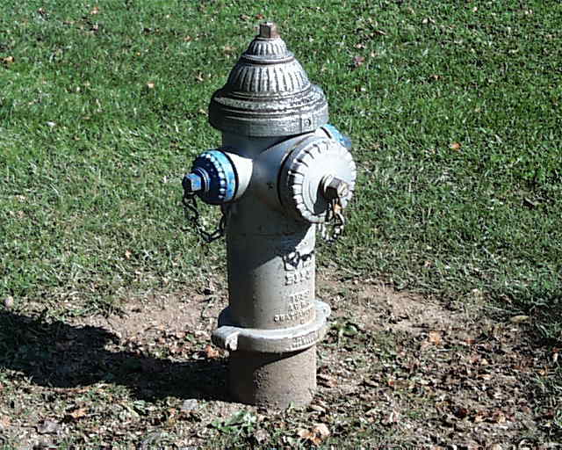

pic.0893.jpg

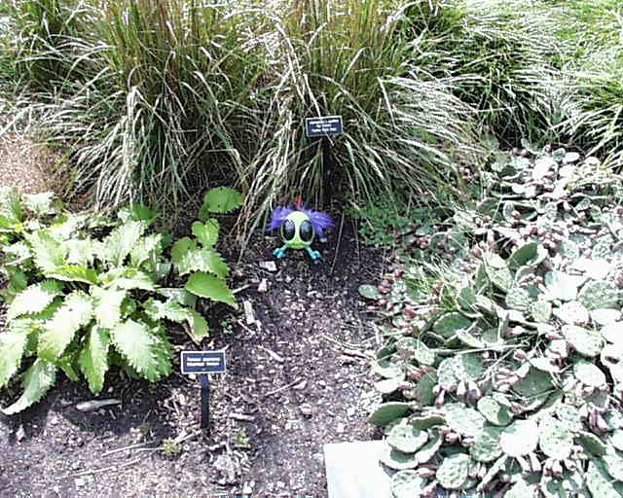

pic.0707.jpg

**Extension 2: Gabor Texture & Color**

* *Feature Vector:*
  + Texture Histogram – Gabor Filters applied in different scales and orientations
  + Color Histogram – L2 Normalized Three Dimensional BGR Histogram for entire image with 8 bins for each color
* *Distance Metric:* Sum-of-Squared-Difference
* *Target Image:* pic.0724.jpg

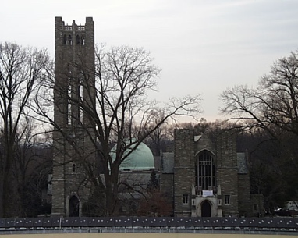

pic.0611.jpg

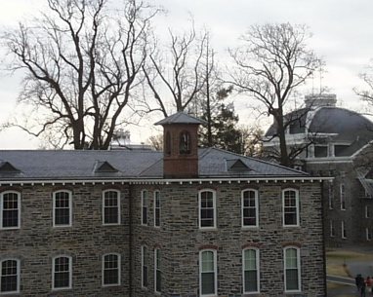

pic.0624.jpg

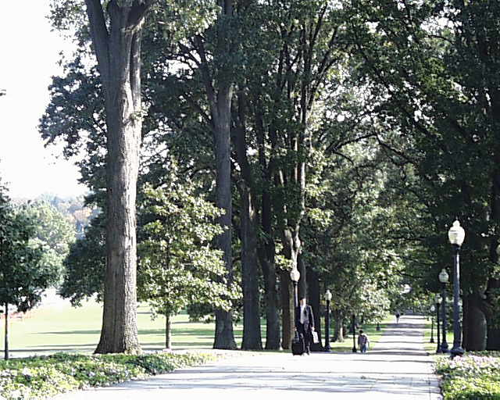

pic.0854.jpg

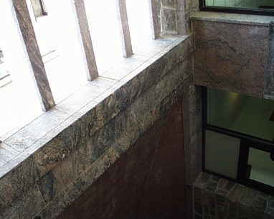

pic.0996.jpg

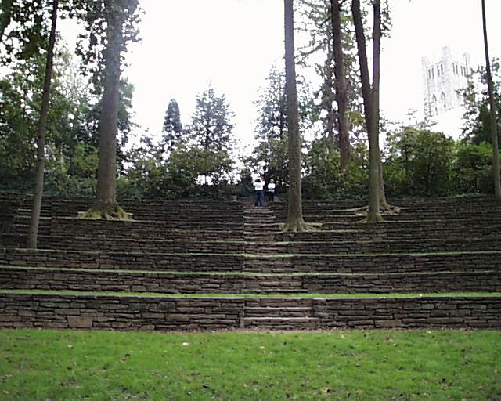

pic.0724.jpg

**Extension 3: Multi-Histogram Matching with Gabor Texture & Color**

* *Feature Vector:*

*Applied on each quadrant of a 2x2 grid (Task 3)*

* + Texture Histogram – Gabor Filters applied in different scales and orientations
  + Color Histogram – L2 Normalized Three Dimensional BGR Histogram for entire image with 8 bins for each color
* *Distance Metric:* Sum-of-Squared-Difference

pic.0756.jpg

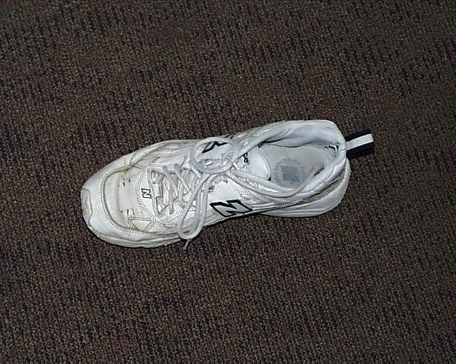

pic.0437.jpg

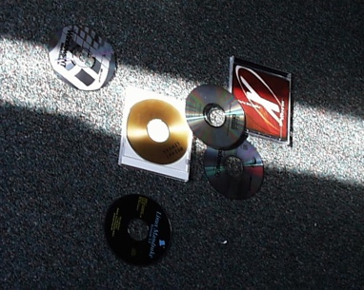

* *Target Image:* pic.0845.jpg

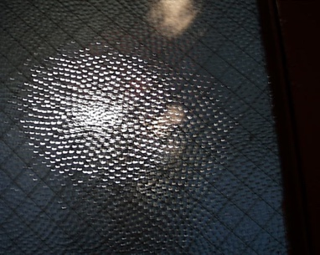

pic.0845.jpg

pic.0666.jpg



pic.0681.jpg

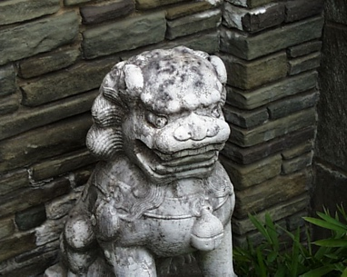

**Extension 4: Gabor Texture & Color at the center of the image**

* *Feature Vector:*

*Applied to only the center section of the image*

* + Texture Histogram – Gabor Filters applied in different scales and orientations
  + Color Histogram – L2 Normalized Three Dimensional BGR Histogram for entire image with 8 bins for each color
* *Distance Metric:* Sum-of-Squared-Difference
* *Target Image:* pic.0872.jpg

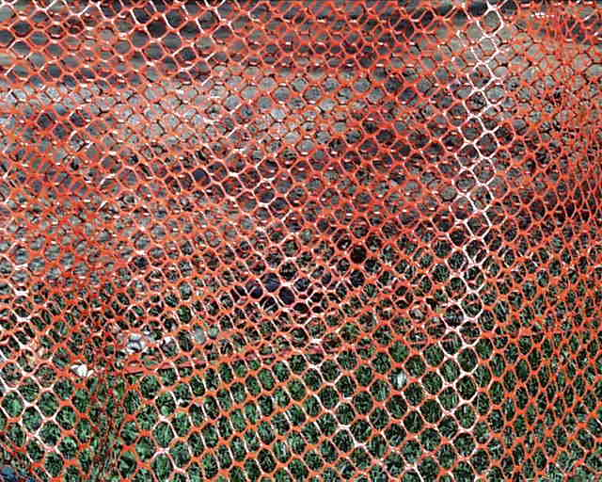

pic.0872.jpg

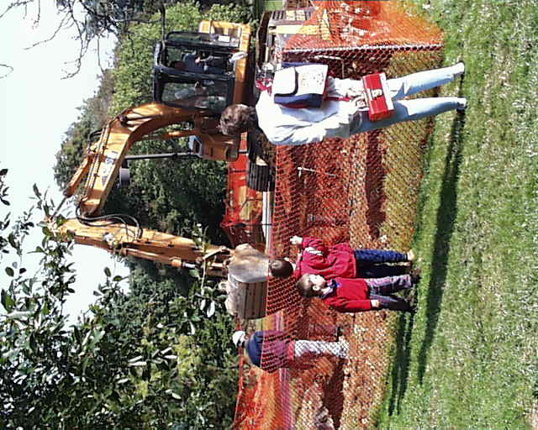

pic.0876.jpg

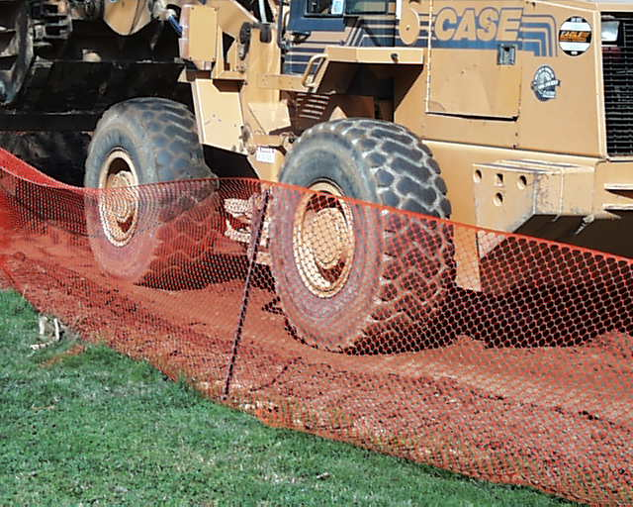

pic.0873.jpg

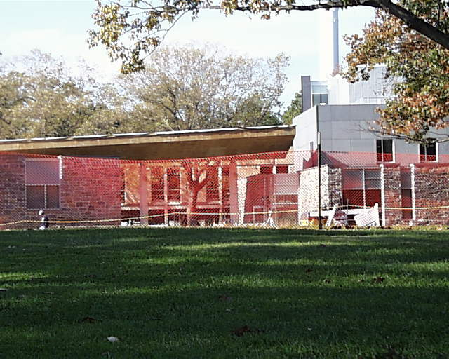

pic.1027.jpg

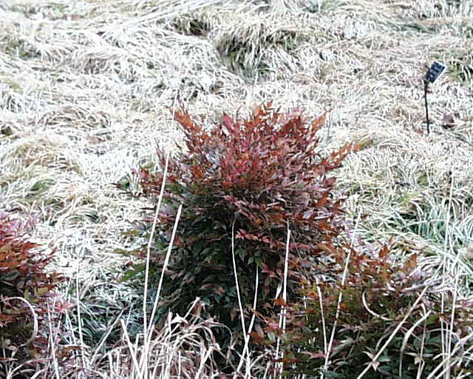

pic.0577.jpg

**Project Learnings and Insights**

This project gave a very good opportunity to work on image matching hands-on. Working on this project helped to reinforce the concepts taught during the lectures. The pattern recognition techniques learnt in this project are very useful and provided a strong foundation in OpenCV.

Working on the distance metric and performing the same task with different weights and different metrics influences the image match, which was very interesting to experiment with.

Working on the extensions was very challenging, and the result was surprising, as repeated interspaced patterns were matched very efficiently with the usage of Gabor filters.

Working on the extension was most difficult as performing trial and error analysis on the getGaborKernel() function by varying the parameters, was time intensive.

**Acknowledgements and Resources used for this project**

* OpenCV Tutorials: <https://docs.opencv.org/4.5.1/index.html>
* getGaborKernel: <https://stackoverflow.com/questions/30071474/opencv-getgaborkernel-parameters-for-filter-bank>
* Gabor Filters: <https://www.researchgate.net/post/Gabor_filter_and_its_applications>
* Histogram Calculation: <https://docs.opencv.org/3.4/d8/dbc/tutorial_histogram_calculation.html>
* getGaborKernel: <https://answers.opencv.org/question/63517/how-to-successfully-implement-a-gabor-filtering/>
* CBIR Gabor: <https://citeseerx.ist.psu.edu/viewdoc/download?doi=10.1.1.63.8420&rep=rep1&type=pdf>